Frameless Led Panel Light

Product Name: Frameless LED Panel Light
Model: HL-PF6060-44W
Specification: Frameless led panel light 595x595x17mm/44w/AC220-240V/4000kelvin/110lm/watts
Dimming: Optional
Areas of application:
Interior application/ Decorative domestic lighting/
Ceiling suspending/suspending and joint together/ embedded mounting( include accessories)
Product advance:
The Frameless structural design makes it special and elegant
5mm thickness diffuser with extremely even light output provides homogenous light distribution.
Hight lumen output, high CRI>80
With stable quality Philip driver and led SMD chip
Material: Aluminum housing + PMMA diffuser
Parameters details:
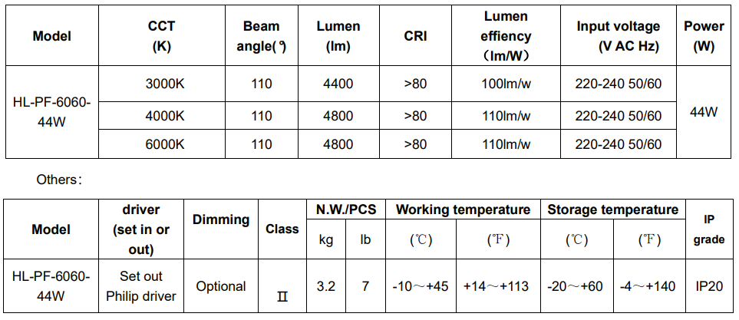
Notes:

- Testing environment temperature: 25±2℃[77±3.6℉]；

- Above testing include LED chip and driver

Product dimension: Length 595mmx Wide 595mm x H 17mm
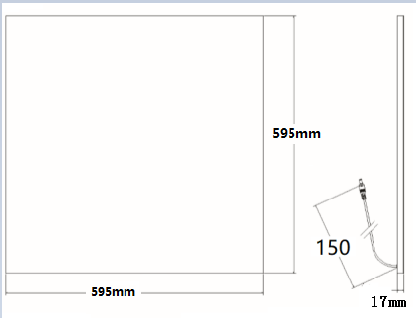
Statement: Product dimension 600x600mm,595x595mm,620x620mm are available.
Installation 1: embedded with spring to ceiling.

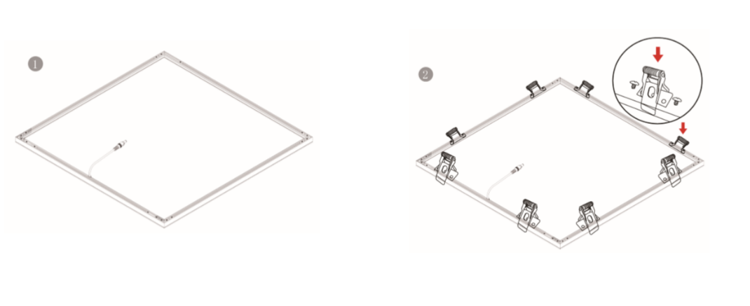
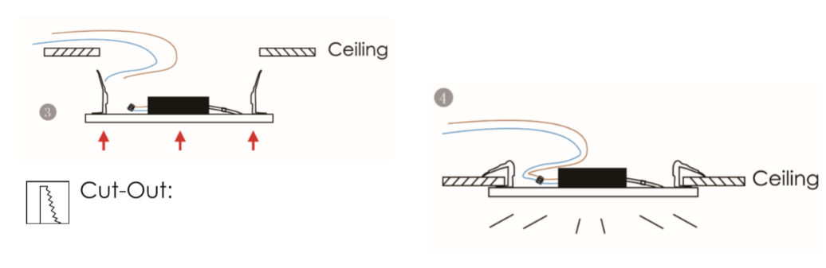
Installation 2: suspending with accessories
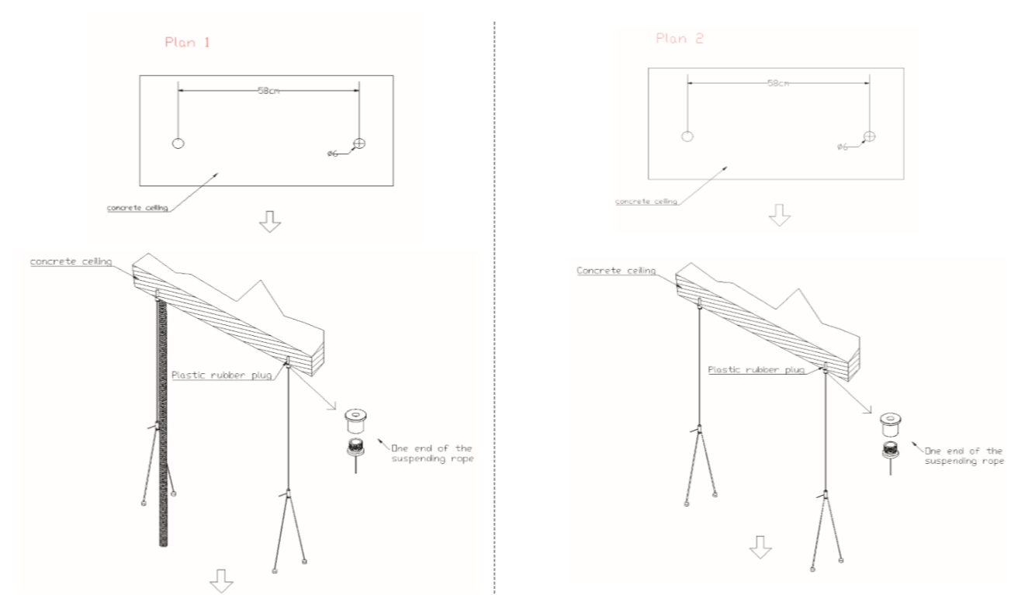
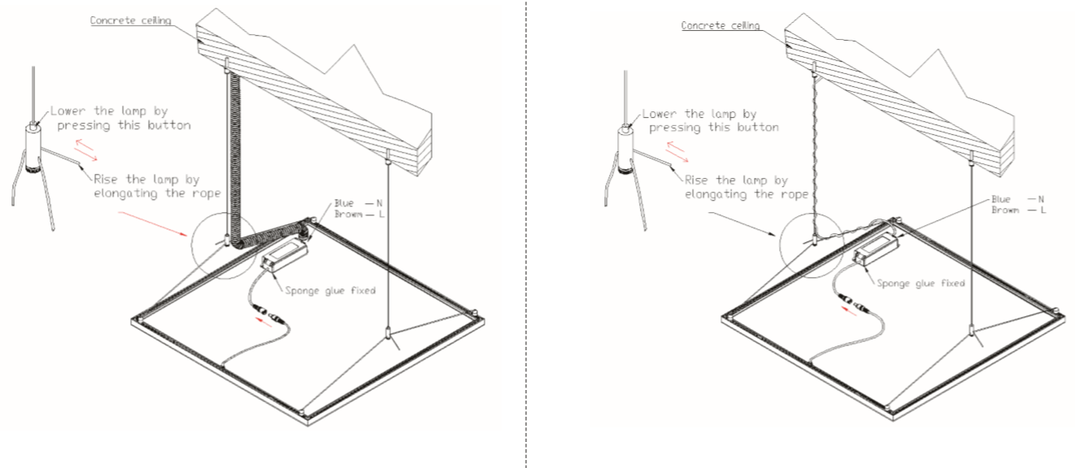
Installation 3: suspending and joint together with accessories
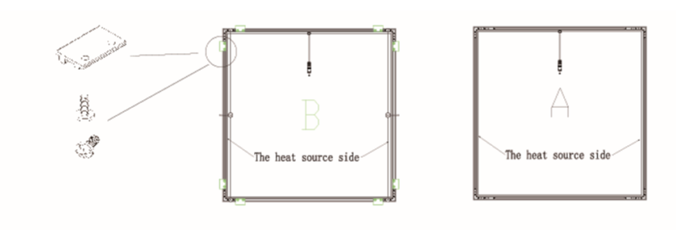
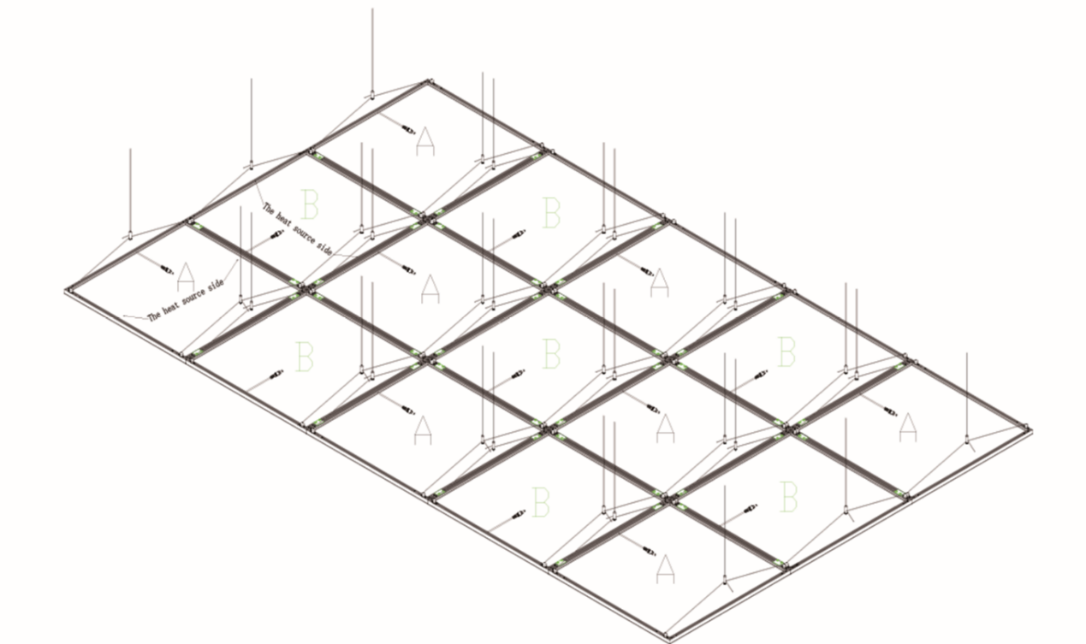
Package details:
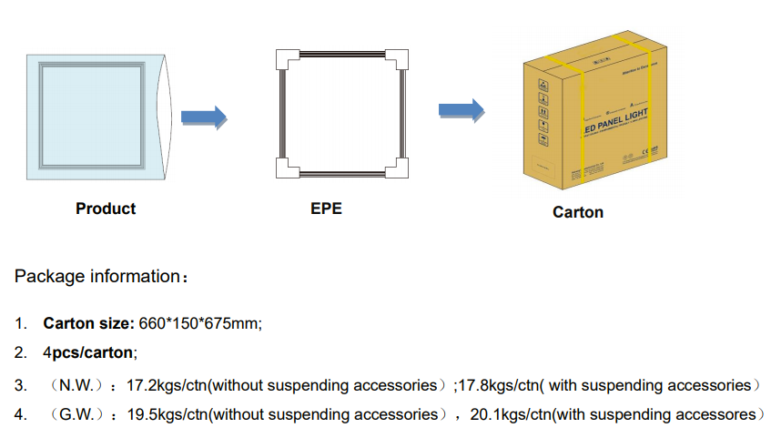
Application show:
